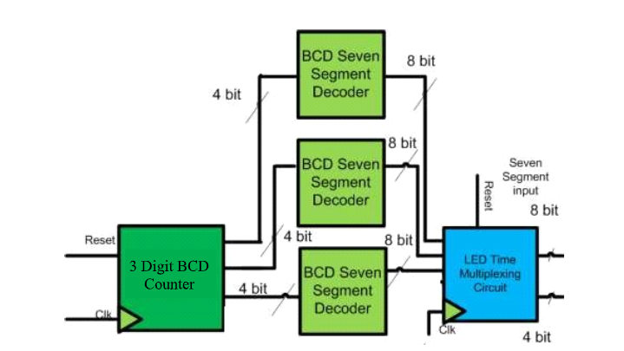**Lab 08**

**4 digit BCD Counter on Multiplexed Seven Segment Display**

**Objective:**

* Learn to use time multiplexed 4 digit Seven Segment display

**Components needed for this lab:**

* Xilinx ISE
* Spartan 6 Board

**BCD to 7-Segment Display:**

In this lab, we will take a BCD input from the user and display the corresponding number on a seven-segment display. The diagram shows the 7-bit code for displaying the digit ‘2.’ tTe enable signal must be low to activate a specific seven-segment display. The Spartan 6 board has four such displays, and later labs will cover time multiplexing techniques to control all four displays using shared input signals (A, B, C, D, E, F, G, Dp).

**Tasks**

**1: Implement a BCD counter that runs from 000 to 999 and shows each BCD digit on the seven segment display.**

**module topModule(CLK,CLR,out_dec,out_mux);**

**input CLK,CLR;**

**output [3:0] out_dec;**

**output [7:0] out_mux;**

**wire slow_clk;**

**wire [17:0] counter_out;**

**wire [3:0] BCDu,BCDt,BCDh;**

**wire [7:0] bcd1,bcd2,bcd3;**

**counter18bit CNT(CLK,CLR,counter_out);**

**Clock_Divider c1(CLK,slow_clk);**

**Task01 t1(slow_clk,CLR,BCDu,BCDt,BCDh);**

**BCD7_seg b1(BCDu,bcd1);**

**BCD7_seg b2(BCDt,bcd2);**

**BCD7_seg b3(BCDh,bcd3);**

**mux4x1 MUX(bcd1,bcd2,bcd3,counter_out[17:16],out_mux);**

**decoder2x4 d1(counter_out[17:16] , out_dec);**

**endmodule**

Verilog Code for Top Module

**module counter18bit(CLK,CLR,counter_out);**

**input CLK,CLR;**

**output reg [17:0] counter_out;**

**always @(posedge CLK)**

**if(CLR | counter_out == 18'b111111111111111111)**

**counter_out <= 18'b000000000000000000;**

**else**

**counter_out <= counter_out + 1'b1;**

**endmodule**

Verilog Code for Up Counter 17-bit

**module counter_3_bit(CLK,CLR,COUNT);**

**input CLK,CLR;**

**output reg [3:0] COUNT;**

**always @(posedge CLK)**

**if(CLR | COUNT == 4'd9)**

**COUNT <= 4'h0;**

**else**

**COUNT <= COUNT + 1;**

**endmodule**

Verilog Code for Up Counter 3-bit

**module BCD7_seg(OUT,COUNT);**

**input [3:0] COUNT;**

**output reg [7:0] OUT;**

**always @(*)**

**case(COUNT)**

**4'b0000 : OUT = 8'b 10000001;//0**

**4'b0001 : OUT = 8'b 11110011;//1**

**4'b0010 : OUT = 8'b 01001001;//2**

**4'b0011 : OUT = 8'b 01100001;//3**

**4'b0100 : OUT = 8'b 00110011;//4**

**4'b0101 : OUT = 8'b 00100101;//5**

**4'b0110 : OUT = 8'b 00000101;//6**

**4'b0111 : OUT = 8'b 11110001;//7**

**4'b1000 : OUT = 8'b 00000001;//8**

**4'b1001 : OUT = 8'b 00100001;//9**

**default : OUT = 8'b 11111111;//default**

**endcase**

**endmodule**

Verilog Code for 7-Segment BCD

**module bcd_3(CLK,CLR,BCDu,BCDt,BCDh**

**);**

**input CLK,CLR;**

**output [3:0] BCDu,BCDt,BCDh;**

**BCD b1(CLK,CLR,BCDu);**

**BCD b2(BCDu[3],CLR,BCDt);**

**BCD b3(BCDt[3],CLR,BCDh);**

**endmodule**

Verilog Code for 3-BCD instantiation

**module Clock_Divider(clock_in,clock_out);**

**input clock_in;**

**output reg clock_out;**

**reg [27:0] counter = 28'd0;**

**parameter DIVISOR = 28'd100000000;**

**always @(posedge clock_in)**

**begin**

**counter <= counter + 28'd1;**

**if(counter>=(DIVISOR-1))**

**counter <=28'd0;**

**clock_out <= (counter>DIVISOR/2)?1'b1:1'b0;**

**end**

**endmodule**

Verilog Code for Clock Divider

# PlanAhead Generated physical constraints

NET "seg[4]" LOC = A3;

NET "seg[5]" LOC = B4;

NET "seg[6]" LOC = A4;

NET "seg[7]" LOC = C4;

NET "seg[8]" LOC = C5;

NET "seg[9]" LOC = D6;

NET "seg[10]" LOC = C6;

NET "seg[3]" LOC = A5;

NET "seg[2]" LOC = B3;

NET "seg[1]" LOC = A2;

NET "seg[0]" LOC = B2;

NET "up_down" LOC = C17;

# PlanAhead Generated IO constraints

NET "clk" PULLUP;

NET "seg[10]" SLEW = FAST;

NET "seg[9]" SLEW = FAST;

NET "seg[8]" SLEW = FAST;

NET "seg[7]" SLEW = FAST;

NET "seg[6]" SLEW = FAST;

NET "seg[5]" SLEW = FAST;

NET "seg[4]" SLEW = FAST;

NET "seg[3]" SLEW = FAST;

NET "seg[2]" SLEW = FAST;

NET "seg[1]" SLEW = FAST;

NET "seg[0]" SLEW = FAST;

NET "up_down" PULLUP;

# PlanAhead Generated physical constraints

INST "clk_BUFGP" LOC = V10;

NET "clk" LOC = V10;

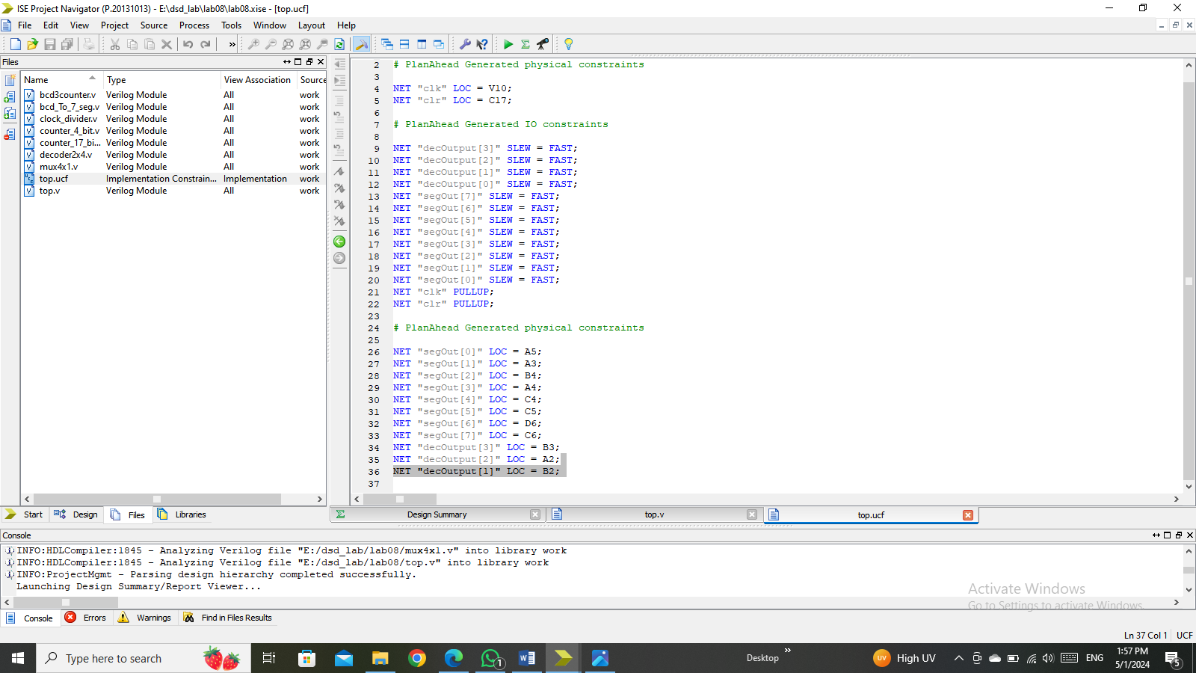

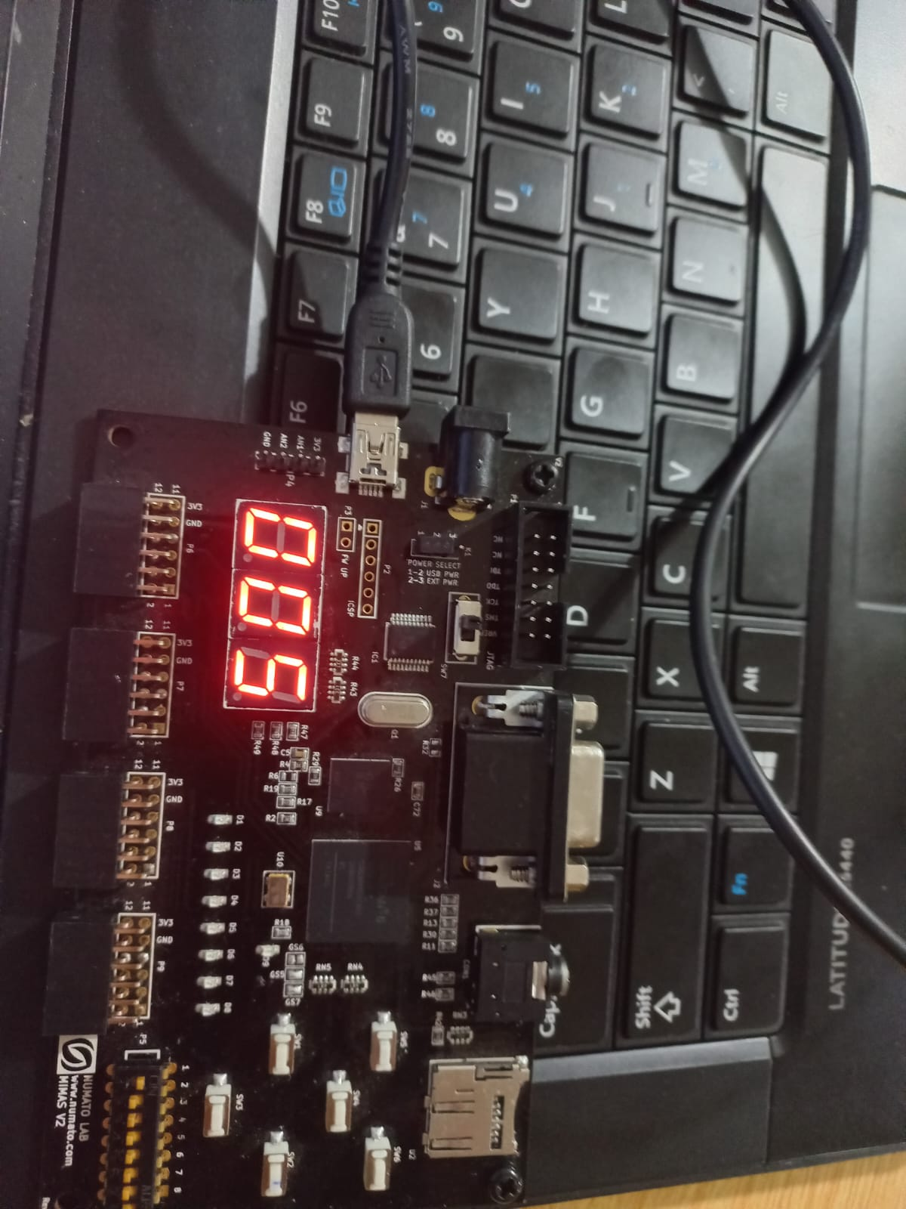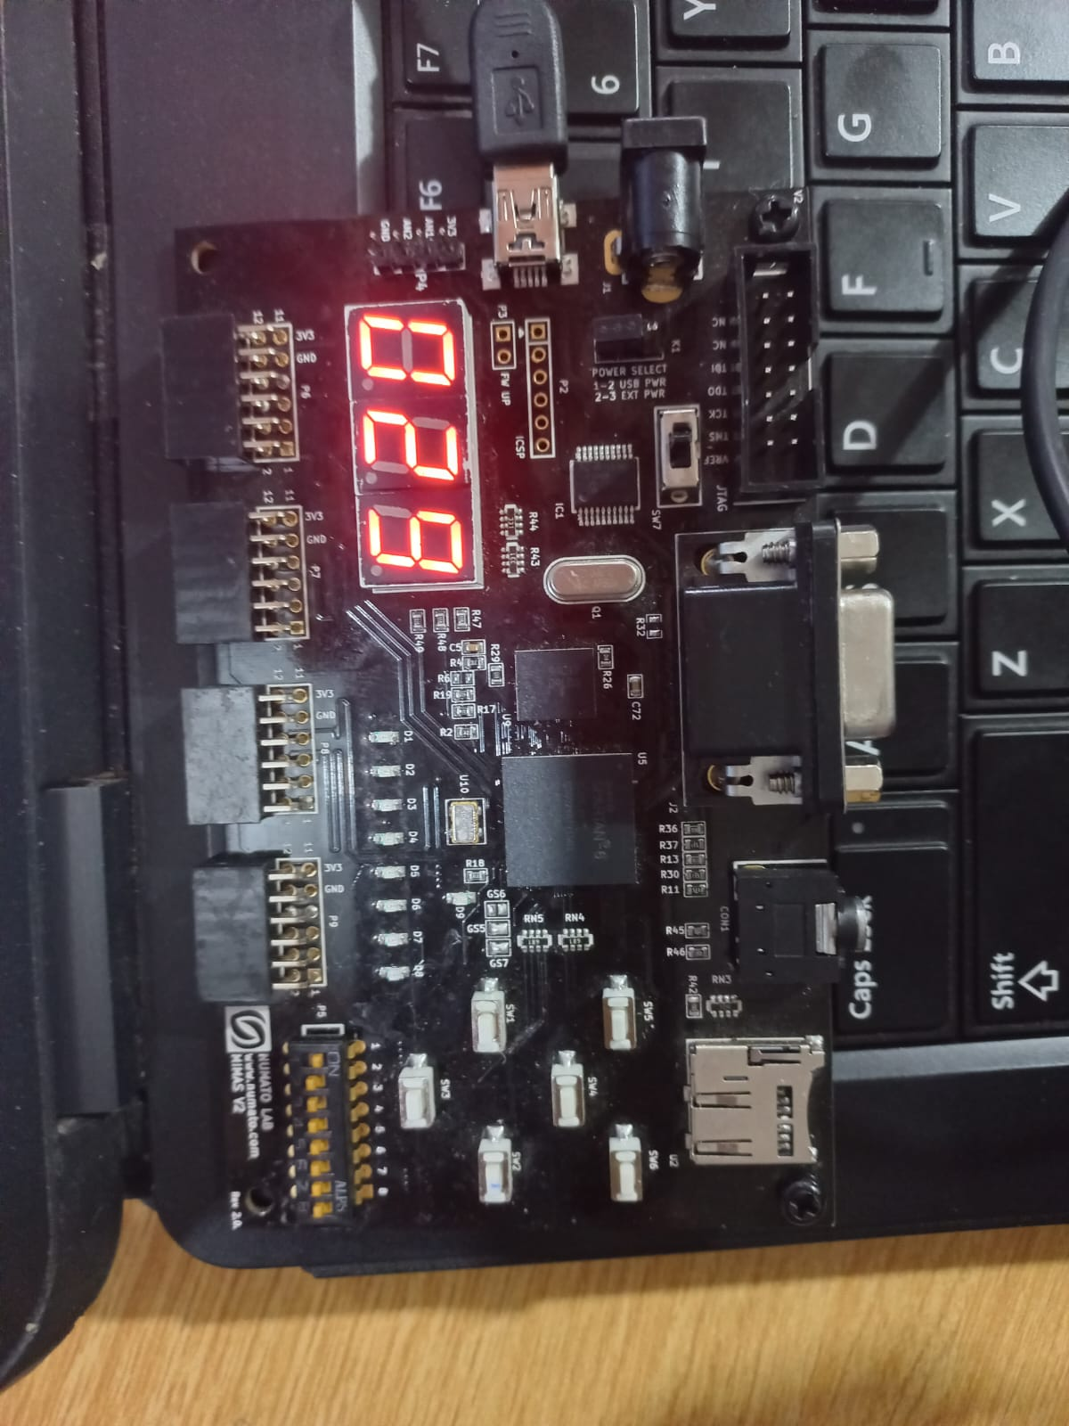UCF File Code fo Top Module

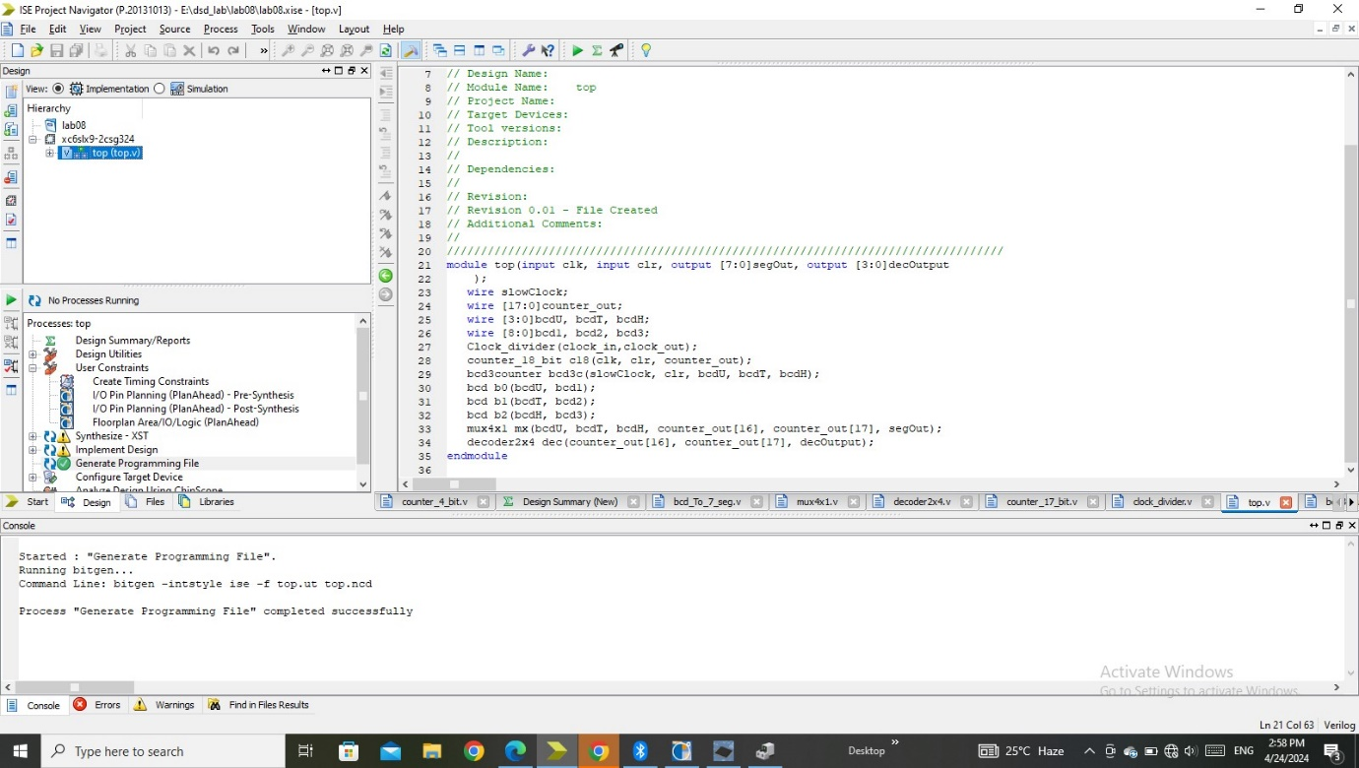

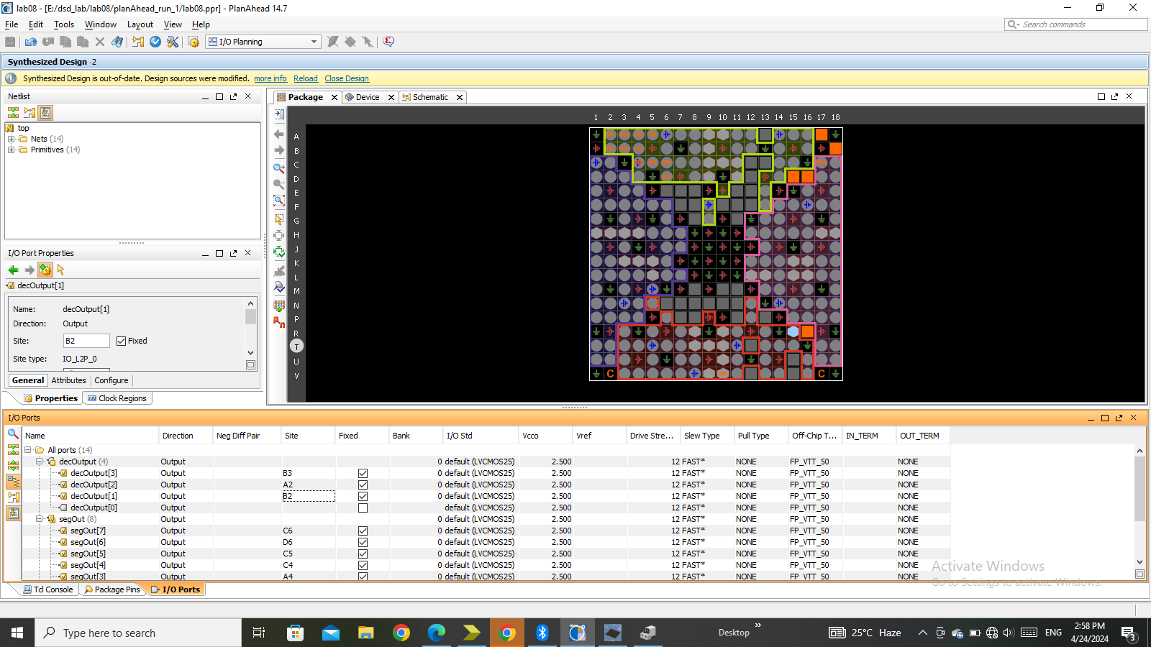

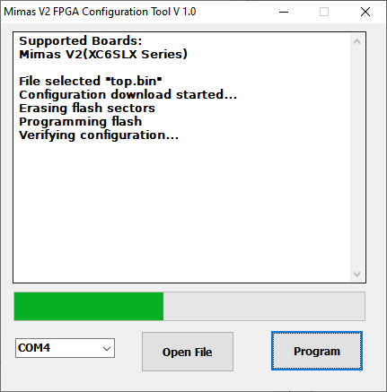

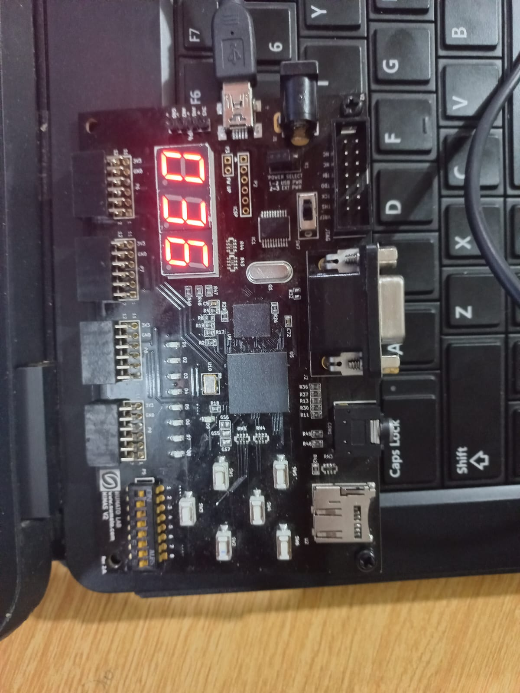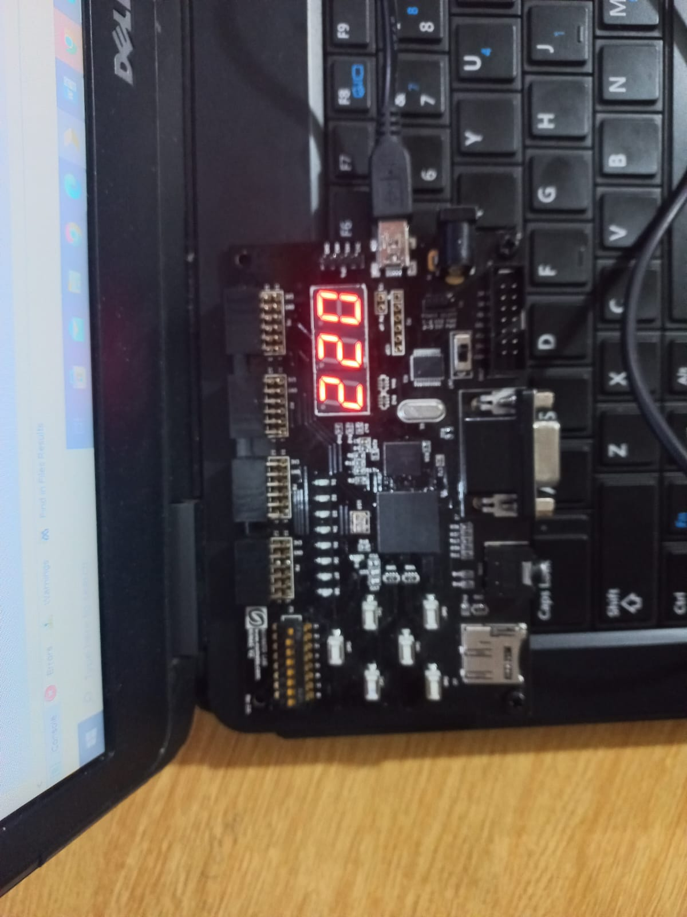

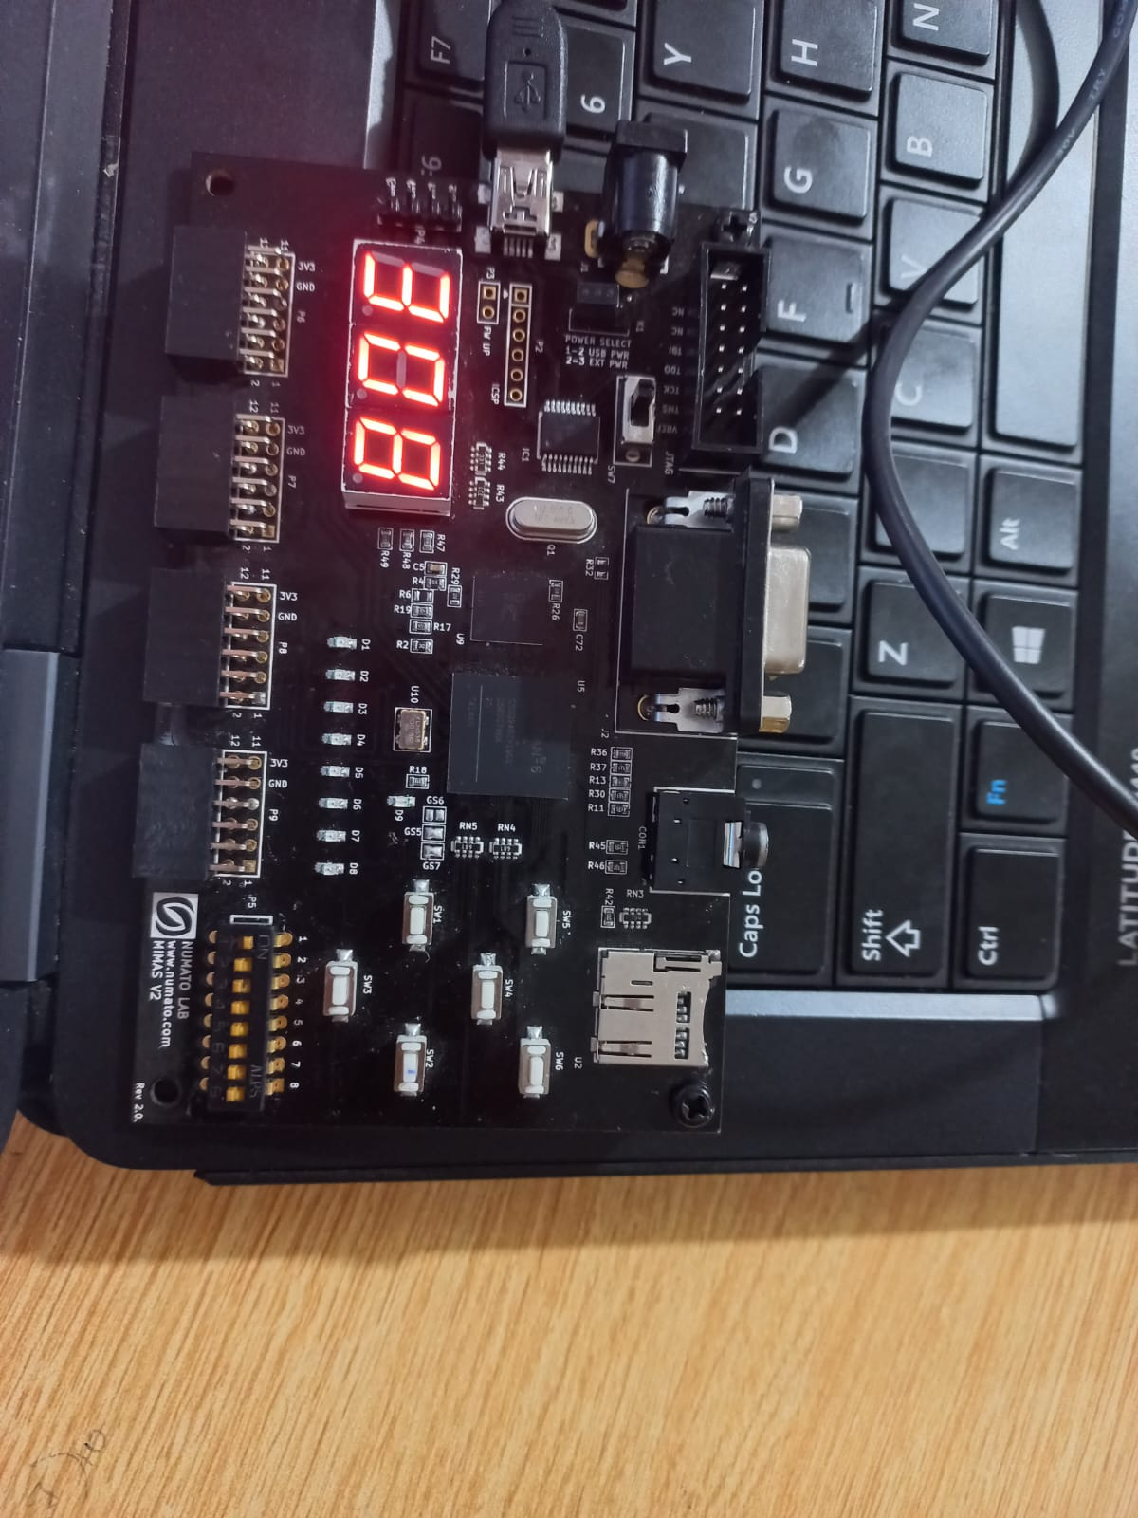

**Conclusion:**

In this lab, we explored how to divide the clock frequency to slow down the counting

process. Additionally, we designed a counter that can count up to 999 in decimal. It was done by using a 1 to 9 counter which was instantiated three times and it’s output was given to the bcd display and then to multiplexer to make output one. There is a decoder that selects one display out of 3 on spartan 6 board.

____________________________________________________________________________________________________________________________